  Resource Folder.
  This Resource folder is a based on best practice guidelines adapted from Internal WSLHD policies and procedures, Nurses & Midwives code of conduct and ACORN standards of Practice.
  This document provides an introduction to B21 in the nursing specialty of Post Anaesthetic Care unit (PACU), for patients undergoing endoscopic procedures. It is a work in progress and will have further iterations. At all times, please exercise best clinical judgment in accordance to best practice guidelines and clinical relevance.
  Table of Contents
  Definitions, Endoscopy & Colonoscopy 2
  Gastroscopy Considerations 3
  Colonoscopy Considerations 4
  Recovery of an Endoscopic patient 5
  Electronic Documentation 6
  Complications 7
  Emergencies 8
  Discharge 9
  Internal Documents & References 10
  
  BLACKTOWN HOSPTIAL
  B21 Endoscopy
  Post Anaesthetic Care Unit (PACU)
  Resource Folder
  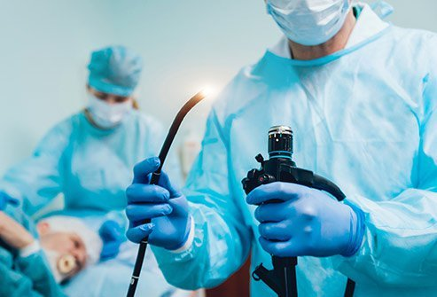
Definitions | 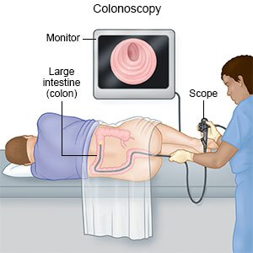 |  | Explanation of Endoscopic procedures  Gastroscopy  A camera inserted through the mouth.  Endoscopy may be used to investigate  symptoms in the digestive system.  It is also used in diagnosis, by performing  a biopsy to check for conditions such  as anemia, bleeding, inflammation,  and cancers of the digestive system.  It can be performed under a general  anaesthetic or sedation.  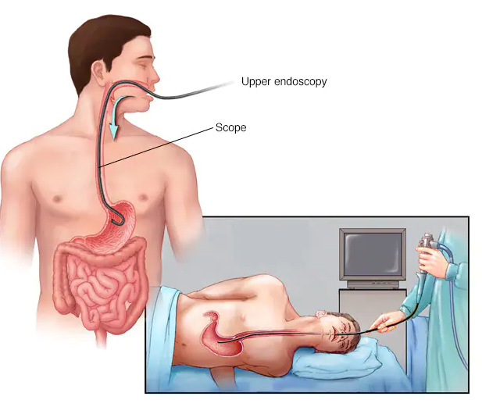  Colonoscopy  An examination of the large bowel and the distal part of the small bowel with a camera passed through the anus. It can provide a visual diagnosis (e.g., ulceration, polyps) and grants the opportunity for biopsy or removal of suspected colorectal cancer lesions. It is usually performed under sedation or general anaesthetic if other procedures are required.
  PACU | Post Anaesthetic Care Unit (B21)
  Endoscopy | Using a camera to look inside the body, usually through the mouth or anus.
  Colonoscopy | Endoscopic procedure of the bowel
  Analgesia | An intervention producing the absence of pain.
  Apnea | Complete absence of breathing
  Conscious Sedation | A drug-induced depression of consciousness during which patients are able to respond purposely to verbal commands or light tactile stimulation.
  Electronic Medical Record (EMR) | An individual’s patient medical record in digital format
  Laryngospasm | Spasm of the vocal cords that temporarily makes it difficult to speak or breathe, common causes are secretions, airway equipment, and pulmonary aspiration in the back of the pharynx.
  Sedation | Depression of a patient’s awareness to the environment and reduction of responsiveness to external stimulation
  SGA | Supraglottic airway
  CERS | Clinical Emergency Response System
  Delayed emergence | A delayed time to fully wake up from anaesthesia
  Post-Op delirium | A confused or agitated state following anaesthesia
  Emesis | The action or process of vomiting
Nursing Considerations
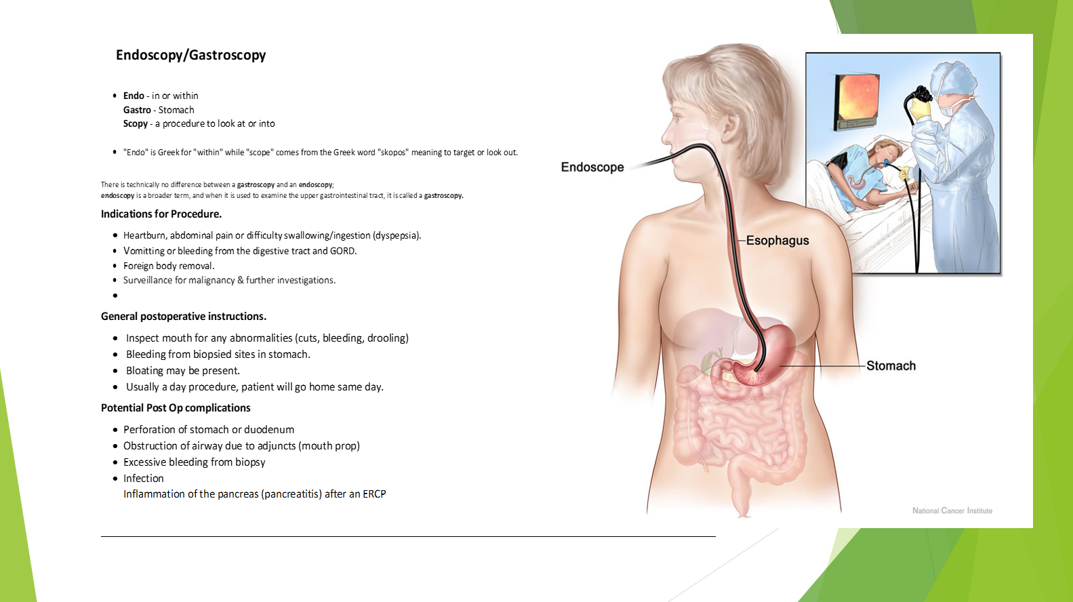

Nursing Considerations
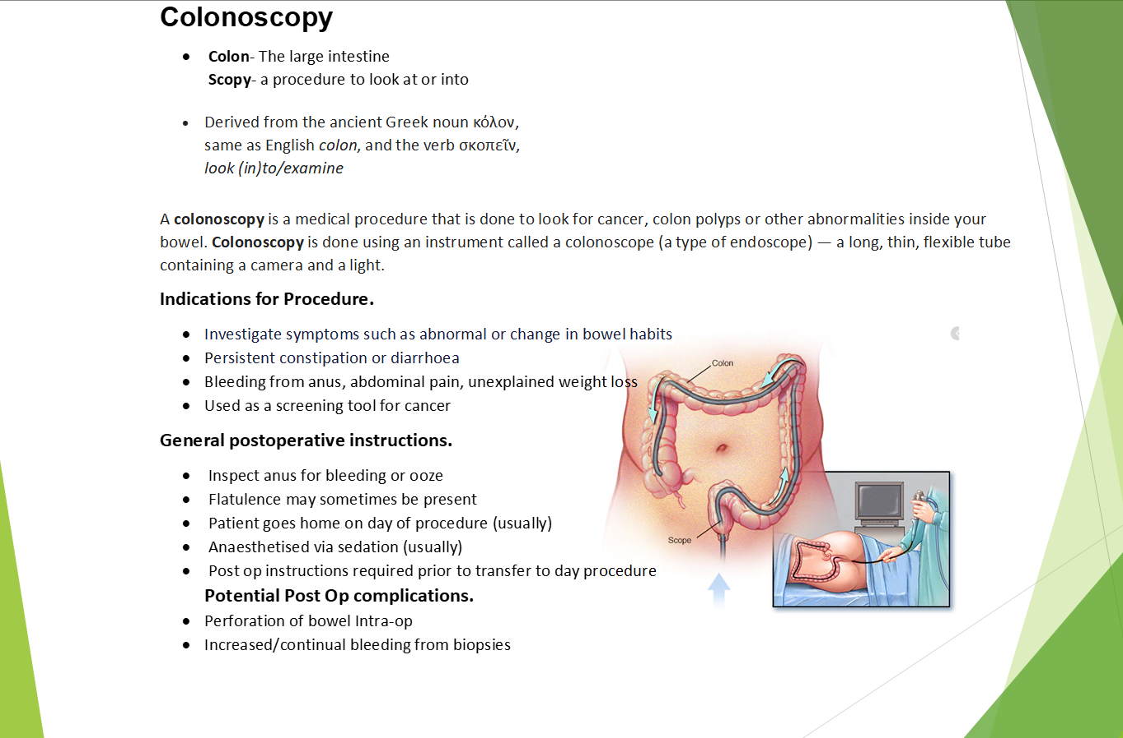
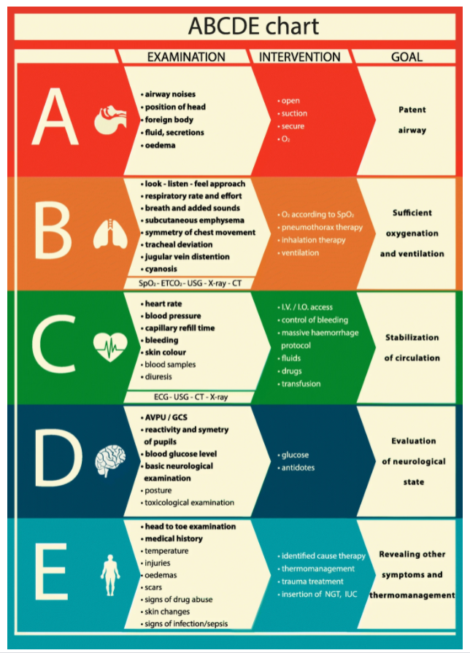
Recovery of the Endoscopic patient
Upon receiving a patient into the PACU, a comprehensive and structured physical assessment should be undertaken.
Peran et al. (2020) provides a summarised version of the A-G assessment
Specific Endoscopic Assessments.
Due to the nature of sedation & general anaesthetic, endoscopic patients are still exposed to the underlying risks associated with anaesthesia and surgical intervention.
Endoscopy -
- Suction of mucus within the upper respiratory tract.
- Obstruction of airway due to apnea.
- Hypotension & bradycardia associated with sedation.
- Injury to oral cavity.
- Bleeding or emesis.
-
Colonoscopy -
- Observe for bloating or stomach cramps.
- Bleeding from anal orifice.
- Flatulence is expected, preserve privacy and dignity.
- Hypotension & bradycardia associated with sedation.
-

(Peran et al. 2020)
Electronic Documentation (EmR + PowerChart)
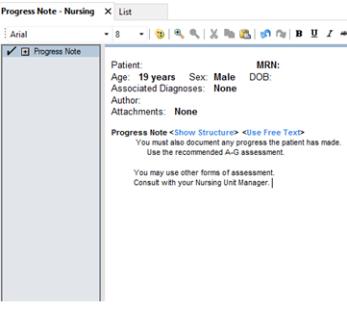

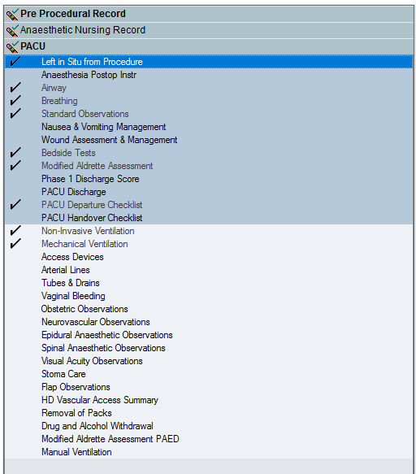
The accepted standard of documentation is the through the EmR & Powerchart system.

You must document the patient’s PACU journey by navigating through the assessments.
You must handover patient care using the PACU handover Checklist marked with a star.

Observations must be a minimum of 15 minute intervals.
Refer to B21 policy on vital sign observations

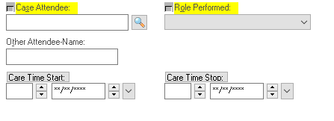
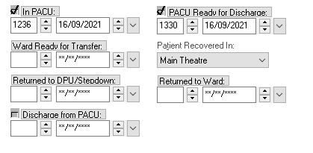

When accepting and handing over a patient. Please register your care for this patient and what role you performed. Ensuring accuracy in the discharge and returning to ward time.

Complications
Complications are characterised by a deviation in the routine procedures in B21. Complications may arise from either surgical or anaesthetic intervention. The most common complications are first observable within the patient’s physiological vital signs. The standard ‘Between The Flags’ model should be followed for all patients in B21.

Complication | Intervention & Assessment
Bleeding | Assess for severity of bleeding and monitor vital signs.  Apply compression if possible and consider escalating to emergency.  If bleeding compromises airway, immediately escalate patient care.
Apnea/obstruction | Monitor vital signs for desaturation & consider patient reposition to alleviate airway.  Provide chin lift, jaw trust or slight neck extension to facilitate air entry.
Delayed emergence | Allow patient to emerge at their own pace, stimulation is acceptable.  periods of more than 30 minutes with delayed emergence should be escalated.
Secretions | Always check suction equipment at beginning of shift, and is within easy reach when needed. Consider Y-suction catheter.
Post-Operative Delirium | Provide care and management of Deliriums using WSYD-PROC203009- Recognising, Responding and Managing Adult Delirium in WSLHD.  The patient is confused and will need help to regain full autonomy
Pain | Manage patient pain with prescribed medications suchs as the fentanyl pain protocol or similar analgesics. Most endoscopic patients do not require analgesics, escalate care if concerned.

Most complications in B21 can be managed using a team based approach.
Refer to your team leader and escalate care to an emergency response if there is no resolution.

Emergencies
General Emergencies
All emergencies should be managed according to the CERS framework.
WSYD-PCP202856- Clinical Emergency Response System (CERS) - Framework for the recognition and management of patients who are deteriorating – WSLHD

Refer to best management strategies in each circumstance, often starting with the activation of the emergency button.
Below are some common emergencies in PACU.

Emergency | Assessment & Intervention
Airway Emergency | Monitor vital signs closely.  Utilising adjunct airway such as guedels or nasopharyngeal. Providing jaw support, chin lift, head tilt. Applying supplementary oxygen at high doses, eg 15.0L/min via HM or BM ventilation.
Anaphylaxis | Administer counteractive agents ie Adrenaline.  Remove substance from patient as soon as possible. Utilise resuscitation trolley, fluids, drug trolley.
Malignant Hyperthermia | Follow best practice guidelines outlined in MH response trolley.  Immediately cease anaesthetic gases. Draw up Dantrolene, provide charcoal filters, icepacks and fluids. Temp checks.
Secretions | Always check suction equipment at beginning of shift, and is within easy reach when needed. Consider Y-suction catheter.
Bleeding | Provide fluid resuscitation, fluid warmer, facilitate blood delivery, take arterial blood gas or Haemacue. Consider infection risk and slippage risk.
Pain | Assess pain using approved standards such as the numerical rating scale or the PQRST model.  Provide reassurance and comfort to patient. Check PRN pain relief and administer. Reposition patient that does not hurt their operative site. Patient may need anaesthetic review if pain does not subside. Check patient history for any chronic pain.

Escalation procedure

If you are unable to control the complication or emergency, escalate the patient care immediately.
Refer to Resource 1.
Clinical Emergency Response System (CERS) - Framework for the recognition and management of patients who are deteriorating – WSLHD
Discharge
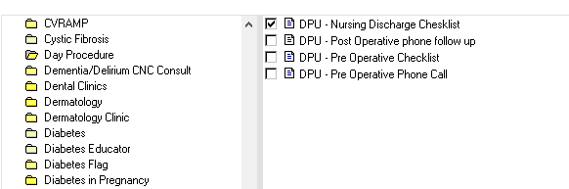
Follow the WSLHD day procedure discharge protocol WSYD-PROC202113
The following forms can be found in the Ad Hoc Charting function on PowerChart.
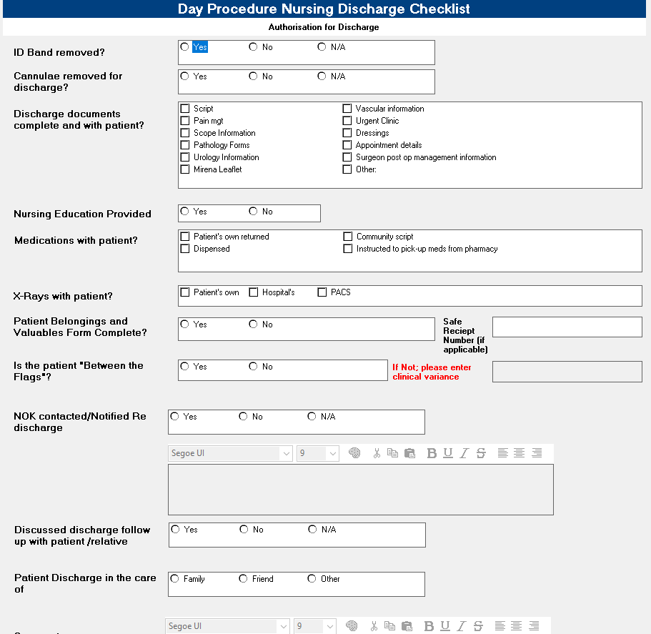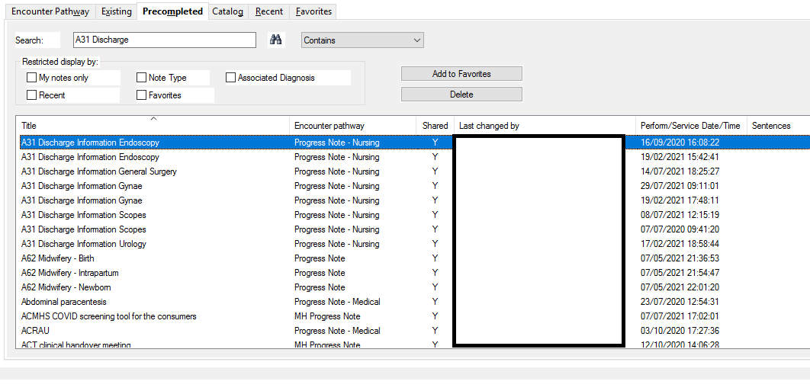
A patient must meet the WSLHD discharge criteria from PACU 1 before being transferred to PACU 2.
In PACU 2, the patient will void, eat, drink, and have physiological assessments ‘between the flags’ prior to discharge.
There must be a support person to transport the patient home and there must be someone to care for the patient overnight.
A discharge summary, procedure report and any relevant documents must be given to the patient (scripts)
Please refer to WSYD-PROC202113 (resources) for further specifics.

Resources & References.
Please refer to the policy & procedures search function in the WSLHD intranet for specific searches
http://virtapp-mas109.nswhealth.net/wslhd_docv3/search/MainSearch.aspx
- WSYD-PROC203146 Adult Inpatient - Clinical Emergency Response System (CERS) – WSLHD
- WSYD-PROC203208 Discharge Criteria for the Adult Patient from Phase 1 Post Anaesthesia Care Unit (PACU) – WSLHD
- WSYD-PROC202113 Admission and Discharge Procedure: A31 Perioperative Services – Blacktown Hospital
- WSYD-PROC203009 Recognising, Responding and Managing Adult Delirium in WSLHD
- WSYD-PCP202856 Clinical Emergency Response System (CERS) - Framework for the recognition and management of patients who are deteriorating – WSLHD

External
Australian and New Zealand College of Anaesthetist (ANZCA) ¬ Professional Documents www.anzca.edu.au Australian
College of Perioperative Nurse (ACORN) Aus Med Australian College of Critical Care Nurses www.acccn.com.au
Australian Society of Post Anaesthesia and Anaesthesia Nurses www.aspaan.org.au Difficult Airway Society www.das.uk.com
Malignant Hyperthermia www.anaesthesia.mg.org.au/malignant-hyperthermia/w1/i1001286
Nurse Anaesthesia Literature Operating Theatre Association Perioperative Nursing Literatures
Peran, D., Kodet, J., Pekara, J., Mala, L., Truhlar, A., Cmorej, P.C., Lauridsen, K.G., Sari, F. and Sykora, R., 2020. ABCDE cognitive aid tool in patient assessment–development and validation in a multicenter pilot simulation study. BMC emergency medicine, 20(1), pp.1-8.

